Artificial
Intelligence AI-2002
Lab 08
Dynamic Bayesian Networks, Markov's Model
National University of Computer & Emerging Sciences – NUCES – Karachi

National University of Computer & Emerging Sciences - NUCES - Karachi
FAST School of Computing
Course Code: AI-2002 Artificial Intelligence Lab
1. Objective 3 2. Bayesian Network 3 2.1 Why use Bayesian Network 3 2.2 Components of a Bayesian Network 3 2.3 Elements of a bayesian Network 4 3. Genie Software Installation 4 4. Burglary Alarm Problem using Bayesian Network 9 5. Markov Model 12 6. Lab Tasks 14
FAST NUCES - Karachi 2

National University of Computer & Emerging Sciences - NUCES - Karachi
FAST School of Computing
1. Objective
1. Introduction to Bayesian Network and Dynamic Bayesian Networks (DBN). 2. Explore how to use python to solve BN, DBN problems and then apply these skills to a couple of challenge problems.
3. Introduction to different Libraries of python.
2. Bayesian Network
A Bayesian Network is a probabilistic graphical model that represents a set of variables and their conditional dependencies through a Directed Acyclic Graph (DAG). It is also referred to as a Bayes network, belief network, decision network, or Bayesian model.Bayesian networks are built from probability distributions and leverage probability theory for tasks such as prediction, anomaly detection, diagnostics, and decision-making under uncertainty
2.1 Why Use Bayesian Network
Real-world systems often involve uncertainty. Bayesian networks help model the probabilistic relationships between multiple events. They are useful in: ● Prediction
● Anomaly detection
● Diagnostic systems
● Automated reasoning and insight generation
● Time series prediction
● Decision-making under uncertainty
● Components of a Bayesian Network
2.2 Components of a Bayesian Network
A Bayesian Network consists of two main components:
1. Directed Acyclic Graph (DAG): Represents the structure of dependencies between variables.
2. Conditional Probability Tables (CPTs): Specify the quantitative strength of those dependencies.
FAST NUCES - Karachi 3

National University of Computer & Emerging Sciences -
NUCES - Karachi
FAST School of Computing
2.3 Elements of a Bayesian Network
● Nodes (or Vertices): Represent random variables in the domain being modeled. These can be:
○ Observable variables (e.g., symptoms)
○ Latent or hidden variables (e.g., disease presence)
● Edges: Directed links between nodes that represent probabilistic dependencies. An edge from node A → B implies that B is conditionally dependent on A. ● Conditional Probability Tables (CPTs): Each non-root node is associated with a CPT that defines the probability distribution of that variable given its parent nodes.
● Parent Nodes: Nodes that have edges pointing to a specific node. A node’s value depends on its parent nodes.
● Root Nodes: Nodes with no incoming edges. These are independent variables or inputs to the system.
● Leaf Nodes: Nodes with no outgoing edges. They often represent outputs or final observed variables.
● Network Structure: The overall connection pattern among the nodes. This structure determines conditional independencies and supports efficient probabilistic inference.
3. Genie Software
https://download.bayesfusion.com/files.html?category=Academia
● Open this link and download the setup following the steps to install the software. After installation it will have this kind of interface
.
FAST NUCES - Karachi 4

National University of Computer & Emerging Sciences - NUCES - Karachi
FAST School of Computing
● There are multiple tabs to draw a network. Let's follow the steps to draw a network with 3 nodes.
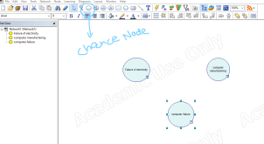
● This is a chance node. Here we have drawn 3 nodes. the next step is to set the links between these. The arrows are in light gray color which suggests that you have not defined the probability tables .
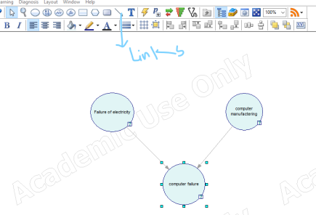FAST NUCES - Karachi 5

National University of Computer & Emerging Sciences - NUCES - Karachi
FAST School of Computing
● To add the tables double click on nodes go to the definition tab. 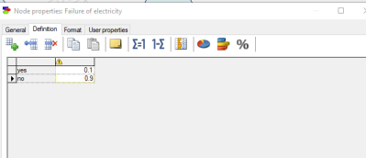
● We had defined the 2 states for failure of electricity with probabilities of individual events.
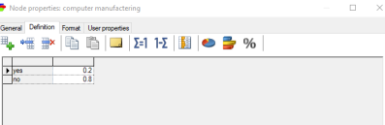FAST NUCES - Karachi 6

National University of Computer & Emerging Sciences - NUCES - Karachi
FAST School of Computing
● Probabilities at second node ( computer malfunctioning) . In the same way, define probabilities for the third node as well.
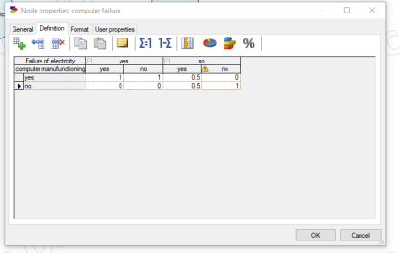● After defining the probability tables, the arc color will change to blue . 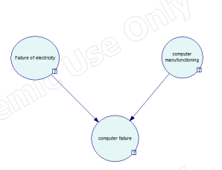
FAST NUCES - Karachi 7
National University of Computer & Emerging Sciences - NUCES - Karachi
FAST School of Computing
● Now everything is defined, the next step is to run the simulation. 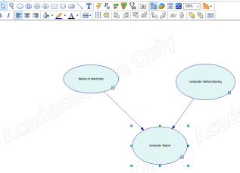
● The question marks have been converted to tick marks once probability tables are properly given.
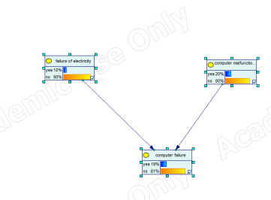● We can simulate any probability value and check for results.
FAST NUCES - Karachi 8
National University of Computer & Emerging Sciences - NUCES - Karachi
FAST School of Computing
4. Burglary Alarm Problem using Bayesian Network
The Burglary Alarm Problem is a standard example used to illustrate Bayesian reasoning. It involves a home alarm system that can be triggered by a burglary or an earthquake. Additionally, two neighbors, John and Mary, may call to report the alarm if they hear it. The Bayesian Network for this problem includes the following five Boolean variables:
● Burglary (B) – Whether a burglary has occurred.
● Earthquake (E) – Whether an earthquake has occurred.
● Alarm (A) – Whether the alarm has gone off.
● JohnCalls (J) – Whether John calls to report the alarm.
● MaryCalls (M) – Whether Mary calls to report the alarm.
Network Structure:
The Alarm (A) is directly influenced by Burglary (B) and Earthquake (E). JohnCalls (J) and MaryCalls (M) depend on Alarm (A).
Conditional Probability Tables (CPTs):
Each node in the network has an associated conditional probability table that quantifies the effects of the parent nodes. For example:
● P(B): Probability of a burglary occurring.
● P(E): Probability of an earthquake occurring.
● P(A | B, E): Probability of the alarm going off, given burglary and earthquake. ● P(J | A): Probability of John calling given the alarm.
● P(M | A): Probability of Mary calling given the alarm.
In a home system, the alarm can be triggered by either a burglary or an earthquake. If the alarm goes off, the system notifies two neighbors, John and Mary, who may call the homeowner. Given that both John and Mary have called, what is the probability that a burglary has actually occurred?
FAST NUCES - Karachi 9
National University of Computer & Emerging Sciences - NUCES - Karachi
FAST School of Computing
from pgmpy.models import DiscreteBayesianNetwork
from pgmpy.factors.discrete import TabularCPD
from pgmpy.inference import VariableElimination
# Step 1: Define the structure of the Bayesian Network
model = DiscreteBayesianNetwork([
('Burglary', 'Alarm'),
('Earthquake', 'Alarm'),
('Alarm', 'JohnCalls'),
('Alarm', 'MaryCalls')
])
# Step 2: Define the CPDs (Conditional Probability Distributions)
# P(Burglary)
cpd_burglary = TabularCPD(variable='Burglary', variable_card=2, values=[[0.999], [0.001]])
# P(Earthquake)
cpd_earthquake = TabularCPD(variable='Earthquake', variable_card=2, values=[[0.998], [0.002]])
# P(Alarm | Burglary, Earthquake)
cpd_alarm = TabularCPD(
variable='Alarm',
variable_card=2,
FAST NUCES - Karachi 10
National University of Computer & Emerging Sciences - NUCES - Karachi
FAST School of Computing
values=[
[0.999, 0.71, 0.06, 0.05], # Alarm = False
[0.001, 0.29, 0.94, 0.95] # Alarm = True
],
evidence=['Burglary', 'Earthquake'],
evidence_card=[2, 2]
)
# P(JohnCalls | Alarm)
cpd_john = TabularCPD(
variable='JohnCalls',
variable_card=2,
values=[
[0.3, 0.9], # JohnCalls = False
[0.7, 0.1] # JohnCalls = True
],
evidence=['Alarm'],
evidence_card=[2]
)
# P(MaryCalls | Alarm)
cpd_mary = TabularCPD(
variable='MaryCalls',
variable_card=2,
values=[
[0.2, 0.99], # MaryCalls = False
[0.8, 0.01] # MaryCalls = True
],
evidence=['Alarm'],
evidence_card=[2]
)
# Step 3: Add CPDs to the model
model.add_cpds(cpd_burglary, cpd_earthquake, cpd_alarm, cpd_john, cpd_mary)
# Step 4: Verify the model
assert model.check_model(), "Model is incorrect"
# Step 5: Perform inference
inference = VariableElimination(model)
# Query: What is the probability of a burglary given that both John and Mary called?
result = inference.query(variables=['Burglary'], evidence={'JohnCalls': 1, 'MaryCalls': 1})
print(result)
FAST NUCES - Karachi 11
National University of Computer & Emerging Sciences - NUCES - Karachi
FAST School of Computing
5. Markov Model
Markov models are a type of probabilistic model used to predict the future state of a system, based on its current state. The defining feature of a Markov model is that the future state of the system depends solely on the present state and not on the sequence of events that preceded it. This is known as the Markov Property or Memoryless Property. In other words, Markov models help predict future states using the current (or observed) states of the system, regardless of how the system arrived at its present state.
A Markov model can be thought of as a finite-state machine where each state has a defined probability of transitioning to other states after one step. These models are ideal for systems that have both hidden (unobservable) and observable states.
Markov models can be classified into two main types:
● Observable Markov Models: Where all states and their transitions are known. ● Hidden Markov Models (HMMs): Where the system has hidden states that cannot be directly observed, and we must infer them based on observable output.
Markov Model Example: The Marble Bag Problem
To better understand Markov models, let's consider a practical example using a bag of marbles. Suppose the bag contains four marbles:
● 2 Red Marbles
● 2 Blue Marbles
The process works as follows:
1. Select a marble randomly from the bag.
2. Note its color and put it back in the bag.
3. Repeat the process multiple times.
After repeating this process several times, you will notice a pattern: The probability of selecting a red marble is always 2 out of 4, or 50%, and similarly, the probability of selecting a blue marble is 50%.
In this case:
● The past history (i.e., the composition of the bag and the number of marbles) determines the future state (i.e., the probability of selecting a particular color of marble).
FAST NUCES - Karachi 12
National University of Computer & Emerging Sciences - NUCES - Karachi
FAST School of Computing
● The Markov Property is evident here because the future selection of a marble (red or blue) only depends on the contents of the bag at the current step (the probability distribution between the red and blue marbles). It does not depend on the order or the sequence of marbles that were previously selected.
Thus, we can model this process using a Markov Chain, where the two states (Red and Blue) transition between each other based on certain probabilities. For this example:
● From a red marble (R), the next state could be either red (R) or blue (B) with equal probabilities (50% each).
● Similarly, from a blue marble (B), the next state could be either red (R) or blue (B) with equal probabilities.
import numpy as np
# Define the states and transition matrix
states = ["Red", "Blue"]
transition_matrix = np.array([[0.5, 0.5], # From Red -> Red or Blue [0.5, 0.5]]) # From Blue -> Red or Blue
# Function to simulate the Markov process
def simulate_markov_process(initial_state, num_steps):
current_state = initial_state
state_sequence = [current_state]
for _ in range(num_steps):
if current_state == "Red":
next_state = np.random.choice(states,
p=transition_matrix[0])
else:
next_state = np.random.choice(states,
p=transition_matrix[1])
state_sequence.append(next_state)
current_state = next_state
return state_sequence
# Simulate the process starting from "Red" and for 10 steps initial_state = "Red"
num_steps = 10
state_sequence = simulate_markov_process(initial_state, num_steps)
# Output the sequence of states
print(f"State sequence for {num_steps} steps starting from {initial_state}:")
print(" -> ".join(state_sequence))
FAST NUCES - Karachi 13
National University of Computer & Emerging Sciences - NUCES - Karachi
FAST School of Computing
Lab Tasks
Task 1
Consider a standard deck of 52 cards. What is the probability of drawing a red card (hearts or diamonds)? Now, given that you have drawn a red card, what is the probability that the card is a heart? Given that the drawn card is a face card (Jack, Queen, King), what is the probability that it is a diamond? Given that the card drawn is a face card, calculate the probability that it is also a spade or a queen.
Task 2
You are given the following Bayesian Network structure to model student exam performance:
Nodes:
● Intelligence (I) — {High, Low}
● StudyHours (S) — {Sufficient, Insufficient}
● Difficulty (D) — {Hard, Easy}
● Grade (G) — {A, B, C}
● Pass (P) — {Yes, No}
Dependencies:
Intelligence, StudyHours, and Difficulty directly affect Grade.
Grade directly affects Pass.
Prior Probabilities:
● P(Intelligence = High) = 0.7, P(Intelligence = Low) = 0.3
● P(StudyHours = Sufficient) = 0.6, P(StudyHours = Insufficient) = 0.4 ● P(Difficulty = Hard) = 0.4, P(Difficulty = Easy) = 0.6
●
Conditional Probabilities (examples):
P(Grade | Intelligence, StudyHours, Difficulty):
(Assume your own valid values, e.g., students with High intelligence, Sufficient study hours, and Easy difficulty are most likely to get A)
● P(Pass | Grade):
● P(Pass = Yes | Grade = A) = 0.95
● P(Pass = Yes | Grade = B) = 0.80
● P(Pass = Yes | Grade = C) = 0.50
Tasks to do
● Construct the Bayesian Network structure diagram showing all dependencies. ● Define the complete Conditional Probability Tables (CPTs) for all nodes.
FAST NUCES - Karachi 14
National University of Computer & Emerging Sciences - NUCES - Karachi
FAST School of Computing
● Implement the Bayesian Network using Python (pgmpy or equivalent). ● Perform inference using Variable Elimination to answer:
● What is the probability that the student passes the exam, given: StudyHours = Sufficient,
Difficulty = Hard
● What is the probability that the student has High Intelligence, given: Pass = Yes
Task 3
You are tasked with building a Bayesian Network to predict the likelihood of a disease (e.g., Flu or Cold) based on the presence of various symptoms, including fever, cough, fatigue, and chills. The network consists of the following nodes:
● Symptoms: Fever, Cough, Fatigue, Chills
● Disease: Flu, Cold
Network Structure:
The Disease node influences the symptoms: Fever, Cough, Fatigue, and Chills.
The Symptoms nodes are observed, and they are conditionally dependent on the Disease node.
Prior Probabilities:
P(Disease):
1. P(Flu) = 0.3
2. P(Cold) = 0.7
P(Symptoms | Disease): (You are to define the following conditional probabilities based on assumptions )
P(Fever | Disease):
1. P(Fever = Yes | Flu) = 0.9
2. P(Fever = Yes | Cold) = 0.5
3. P(Fever = No | Flu) = 0.1
4. P(Fever = No | Cold) = 0.5
P(Cough | Disease):
1. P(Cough = Yes | Flu) = 0.8
2. P(Cough = Yes | Cold) = 0.6
3. P(Cough = No | Flu) = 0.2
4. P(Cough = No | Cold) = 0.4
FAST NUCES - Karachi 15
National University of Computer & Emerging Sciences - NUCES - Karachi
FAST School of Computing
P(Fatigue | Disease):
1. P(Fatigue = Yes | Flu) = 0.7
2. P(Fatigue = Yes | Cold) = 0.3
3. P(Fatigue = No | Flu) = 0.3
4. P(Fatigue = No | Cold) = 0.7
P(Chills | Disease):
1. P(Chills = Yes | Flu) = 0.6
2. P(Chills = Yes | Cold) = 0.4
3. P(Chills = No | Flu) = 0.4
4. P(Chills = No | Cold) = 0.6
Construct the Bayesian Network:
Draw the structure of the Bayesian Network based on the dependencies given above. Define the Conditional Probability Tables (CPTs)
Define reasonable CPTs for all nodes (Disease, Fever, Cough, Fatigue, and Chills) based on the given probabilities. You may assume the probabilities if necessary.
Perform Inference Task 1:
Use the Bayesian Network to calculate the posterior probability of the Disease (Flu or Cold), given the following symptoms:
● Fever = Yes
● Cough = Yes
Perform Inference Task 2:
Add a new symptom: Chills.
Update the Bayesian Network to compute the posterior probability of the Disease (Flu or Cold), given the following symptoms:
● Fever = Yes
● Cough = Yes
● Chills = Yes
Perform Inference Task 3:
Given that the disease is Flu, calculate the probability that the person also has Fatigue. ● What is P(Fatigue = Yes | Disease = Flu)?
FAST NUCES - Karachi 16
National University of Computer & Emerging Sciences - NUCES - Karachi
FAST School of Computing
Task 4
Define a simple Markov Model with three weather states: Sunny, Cloudy, and Rainy. Create a transition matrix for the weather states, specifying the probabilities of transitioning from one state to another (e.g., from Sunny to Cloudy, or from Cloudy to Rainy). Simulate the weather for the next 10 days, starting with a Sunny day, using the Markov Model. Calculate the probability of having at least 3 rainy days over the 10-day period.
FAST NUCES - Karachi 17

